GitHub

Perform Registration @ <https://github.com>



Steps

Enter desired account information

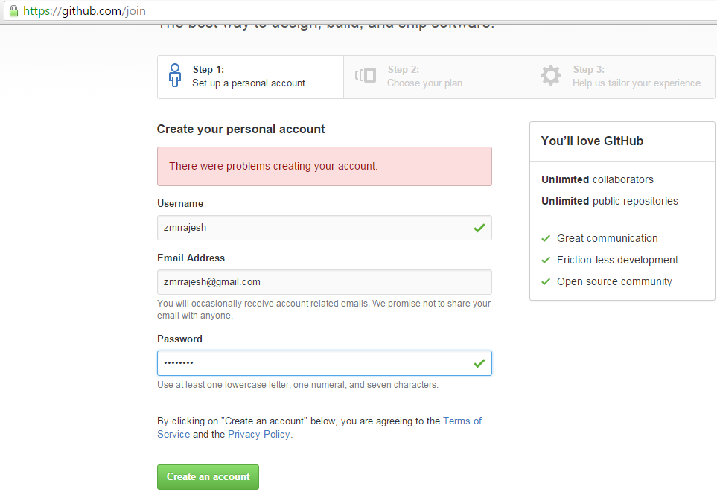

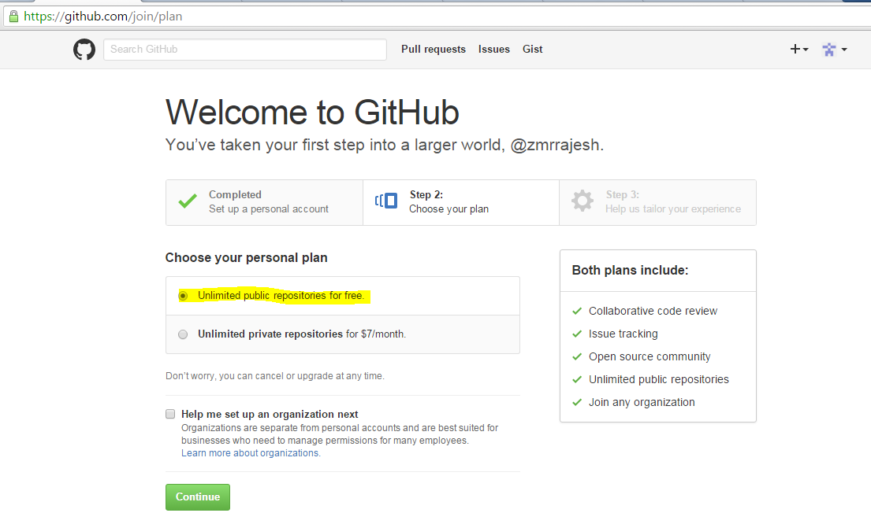

Verify account by login to your account



Create New Repository



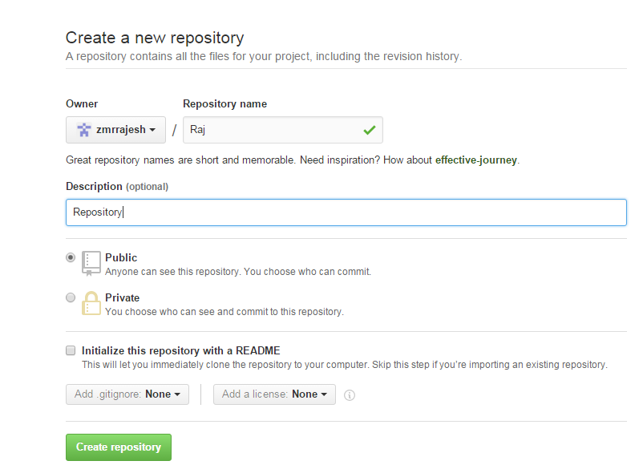

Informative link:

<http://www.howtogeek.com/180167/htg-explains-what-is-github-and-what-do-geeks-use-it-for/>

Other:

Installs

For Windows (for Desktop, drag n drop!)

<https://desktop.github.com>

For DOS (command line)

<https://git-for-windows.github.io>